IELTS Academic Writing Task 1 Exercises: Overview

Now write the Overview of the tasks for which you have already written the Introduction.

Pie Chart Question Samples
You should spend about 20 minutes on this task.

The pie charts below compare the proportion of energy capacity in gigawatts (GW) in 2015 with the predictions for 2040.

Summarise the information by selecting and reporting the main features and make comparisons where relevant.

Write at least 150 words.

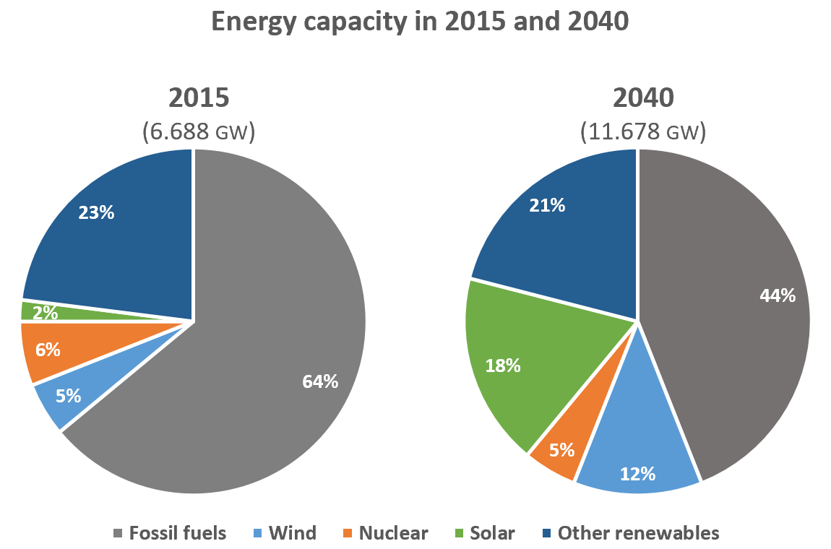

Overview: ----------------------------------------------------------------------------------------------------------------
------------------------------------------------------------------------------------------------------------------------------
------------------------------------------------------------------------------------------------------------------------------
------------------------------------------------------------------------------------------------------------------------------
------------------------------------------------------------------------------------------------------------------------------

You should spend about 20 minutes on this task.

The charts give information about employment in the UK in 1998 and 2012.

Summarise the information by selecting and reporting the main features and make comparisons where relevant.

Write at least 150 words.

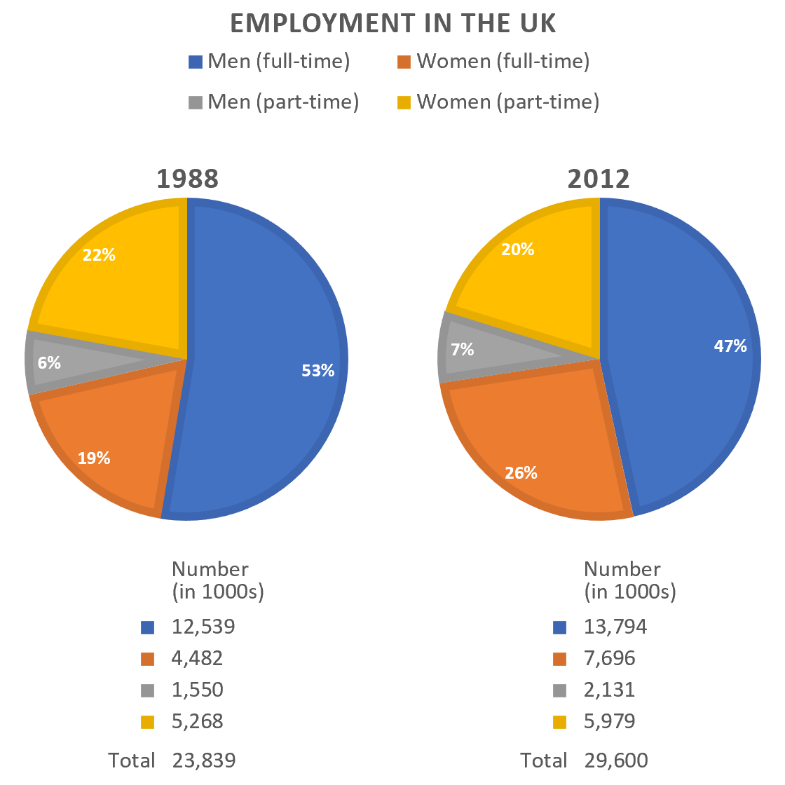
Overview: -----------------------------------------------------------------------------------------------------------------------------------------------------------------------------------------------------------------------------------------------
------------------------------------------------------------------------------------------------------------------------------
------------------------------------------------------------------------------------------------------------------------------
------------------------------------------------------------------------------------------------------------------------------

You should spend about 20 minutes on this task.

The pie charts compare ways of accessing the news in Canada and Australia.

Summarise the information by selecting and reporting the main features and make comparisons where relevant.

Write at least 150 words.

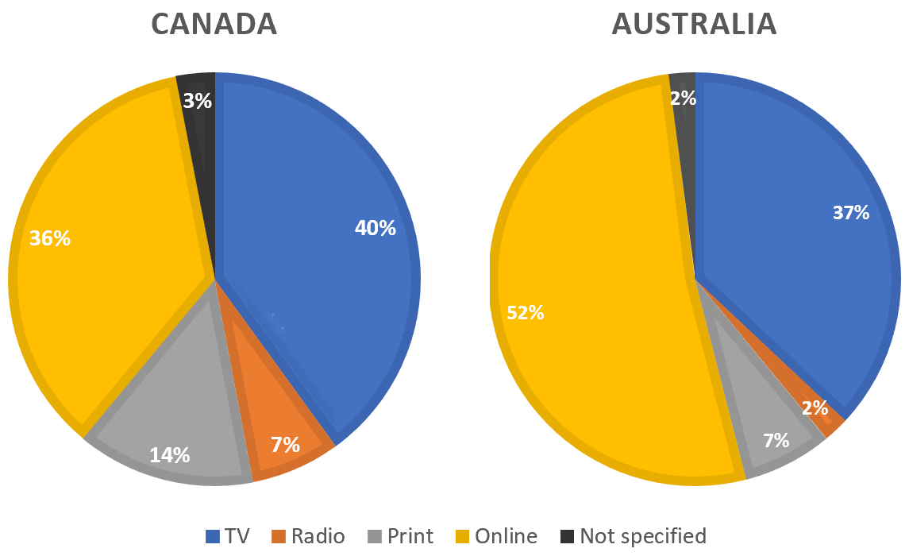

Overview: -----------------------------------------------------------------------------------------------------------------------------------------------------------------------------------------------------------------------------------------------
------------------------------------------------------------------------------------------------------------------------------
------------------------------------------------------------------------------------------------------------------------------
------------------------------------------------------------------------------------------------------------------------------

You should spend about 20 minutes on this task.

The pie charts below show the devices people in the 18 to 25 age group use to watch television in Canada in two different years.

Summarise the information by selecting and reporting the main features, and make comparisons where relevant.

Write at least 150 words.

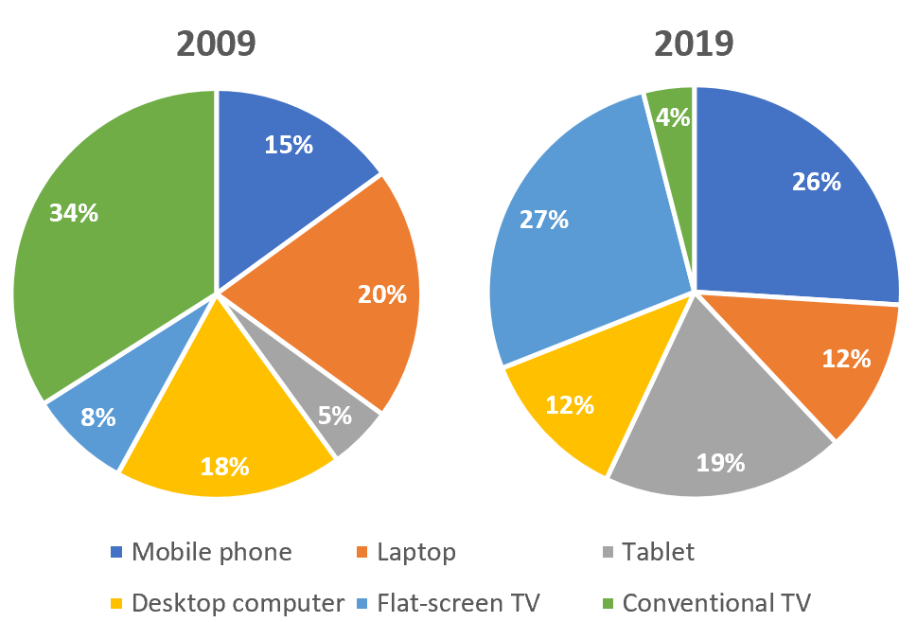

Overview: -----------------------------------------------------------------------------------------------------------------------------------------------------------------------------------------------------------------------------------------------
------------------------------------------------------------------------------------------------------------------------------
------------------------------------------------------------------------------------------------------------------------------
------------------------------------------------------------------------------------------------------------------------------

Map Question Samples
You should spend about 20 minutes on this task.

Below is a map of the city of Brandfield. City planners have decided to build a new shopping mall for the area, and two sites, S1 and S2 have been proposed.

Summarise the information by selecting and reporting the main features and make comparisons where relevant.

Write at least 150 words.

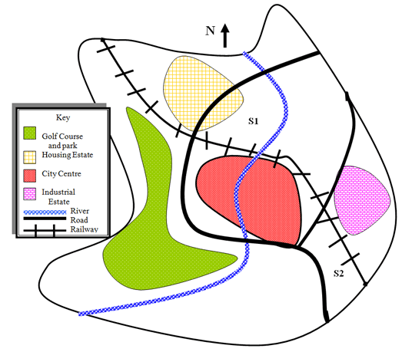

Overview: -----------------------------------------------------------------------------------------------------------------------------------------------------------------------------------------------------------------------------------------------
------------------------------------------------------------------------------------------------------------------------------
------------------------------------------------------------------------------------------------------------------------------
------------------------------------------------------------------------------------------------------------------------------

You should spend about 20 minutes on this task.

The maps below show the town of Langley in 1910 and 1950.

Summarise the information by selecting and reporting the main features and make comparisons where relevant.

Write at least 150 words.

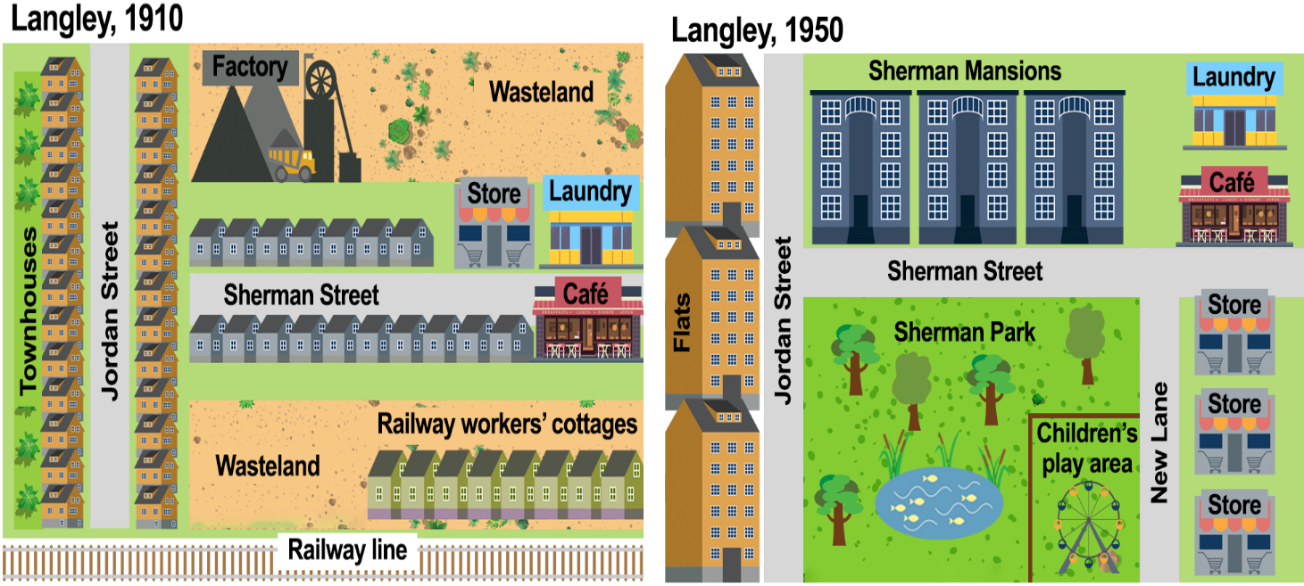

Overview: -----------------------------------------------------------------------------------------------------------------------------------------------------------------------------------------------------------------------------------------------
------------------------------------------------------------------------------------------------------------------------------
------------------------------------------------------------------------------------------------------------------------------
------------------------------------------------------------------------------------------------------------------------------

You should spend about 20 minutes on this task.

The map below shows the changes in an American town between 1948 and 2010.

Summarise the information by selecting and reporting the main features and make comparisons where relevant.

Write at least 150 words.

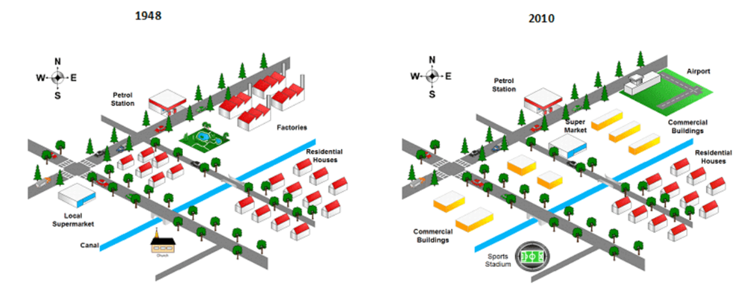

Overview: -----------------------------------------------------------------------------------------------------------------------------------------------------------------------------------------------------------------------------------------------
------------------------------------------------------------------------------------------------------------------------------
------------------------------------------------------------------------------------------------------------------------------
------------------------------------------------------------------------------------------------------------------------------

You should spend about 20 minutes on this task.

The map below is of the town of Garlsdon. A new supermarket (S) is planned for the town. The map shows two possible sites for the supermarket.

Summarise the information by selecting and reporting the main features and make comparisons where relevant.

Write at least 150 words.

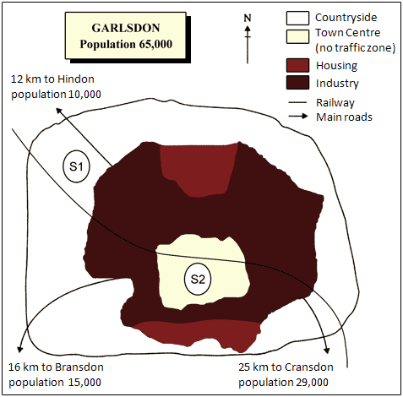

Overview: -----------------------------------------------------------------------------------------------------------------------------------------------------------------------------------------------------------------------------------------------
------------------------------------------------------------------------------------------------------------------------------
------------------------------------------------------------------------------------------------------------------------------
------------------------------------------------------------------------------------------------------------------------------

Bar Chart Question Samples
You should spend about 20 minutes on this task.

The graph below shows the changes in the maximum number of Asian elephants between 1994 and 2007.

Summarise the information by selecting and reporting the main features and make comparisons where relevant.

Write at least 150 words.

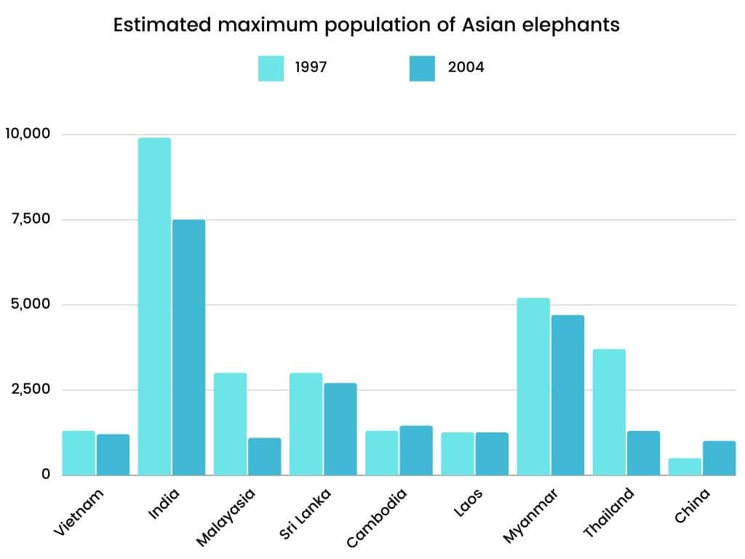

Overview: -----------------------------------------------------------------------------------------------------------------------------------------------------------------------------------------------------------------------------------------------
------------------------------------------------------------------------------------------------------------------------------
------------------------------------------------------------------------------------------------------------------------------
------------------------------------------------------------------------------------------------------------------------------

You should spend about 20 minutes on this task.

The chart below gives information about global population percentages and distribution of wealth by region.

Summarise the information by selecting and reporting the main features and make comparisons where relevant.

Write at least 150 words.

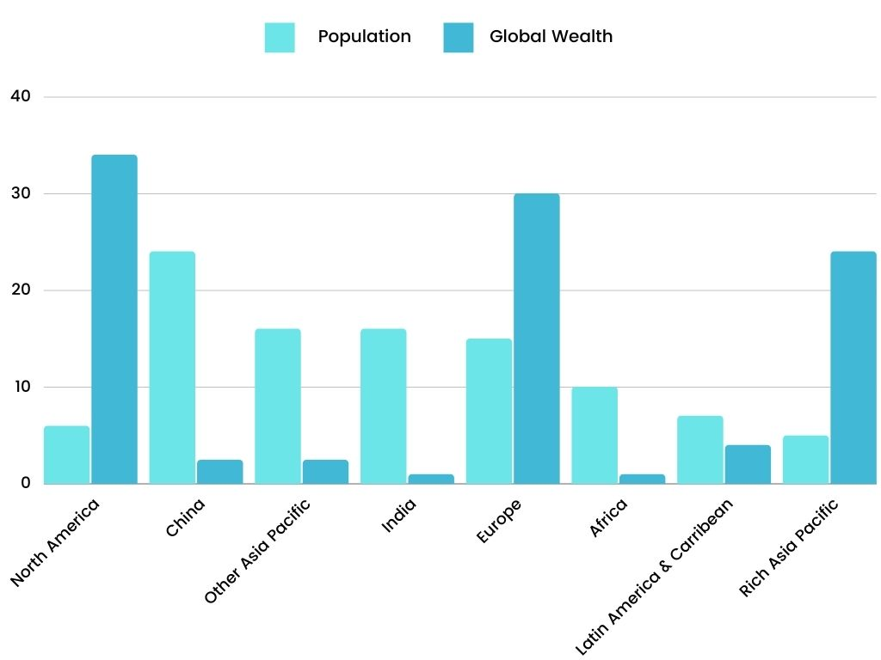

Overview: -----------------------------------------------------------------------------------------------------------------------------------------------------------------------------------------------------------------------------------------------
------------------------------------------------------------------------------------------------------------------------------
------------------------------------------------------------------------------------------------------------------------------
------------------------------------------------------------------------------------------------------------------------------

You should spend about 20 minutes on this task.

The bar chart shows different methods of waste disposal in four cities; Toronto, Madrid, Kuala Lumpur and Amman.

Summarise the information by selecting and reporting the main features and make comparisons where relevant.

Write at least 150 words.

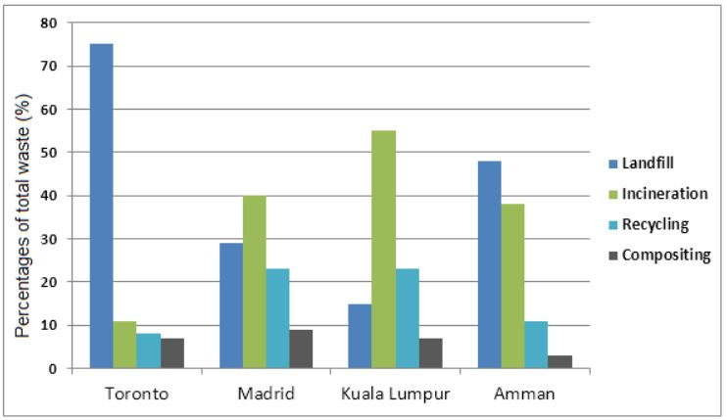

Overview: -----------------------------------------------------------------------------------------------------------------------------------------------------------------------------------------------------------------------------------------------
------------------------------------------------------------------------------------------------------------------------------
------------------------------------------------------------------------------------------------------------------------------
------------------------------------------------------------------------------------------------------------------------------

You should spend about 20 minutes on this task.

The chart below shows the spending (in millions) by 18-20-year-olds in one country on five different products in 2010 and 2014.

Summarise the information by selecting and reporting the main features and make comparisons where relevant.

Write at least 150 words.

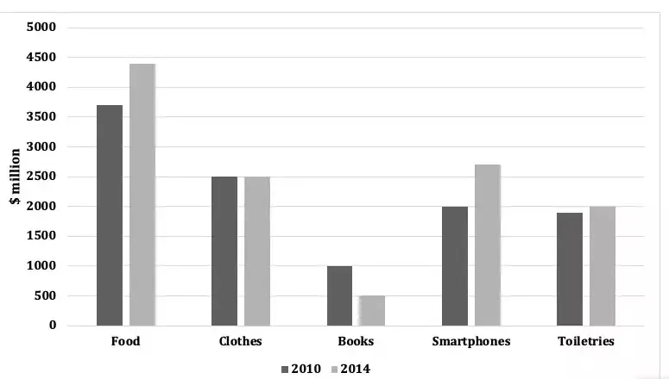

Overview: -----------------------------------------------------------------------------------------------------------------------------------------------------------------------------------------------------------------------------------------------
------------------------------------------------------------------------------------------------------------------------------
------------------------------------------------------------------------------------------------------------------------------
------------------------------------------------------------------------------------------------------------------------------

Line Graph Question Samples
You should spend about 20 minutes on this task.

The graph shows the number of visitors to four international museums between 1980 and 2015.

Summarise the information by selecting and reporting the main features and make comparisons where relevant.

Write at least 150 words.

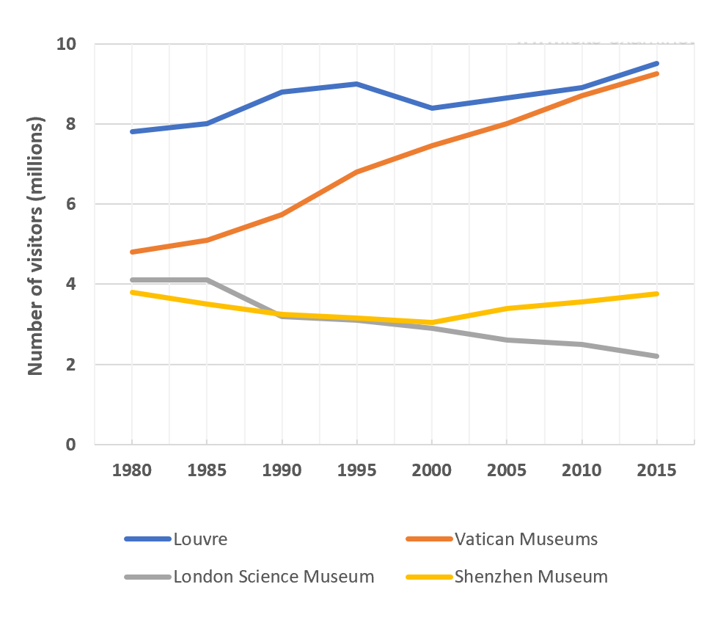

Overview: -----------------------------------------------------------------------------------------------------------------------------------------------------------------------------------------------------------------------------------------------
------------------------------------------------------------------------------------------------------------------------------
------------------------------------------------------------------------------------------------------------------------------
------------------------------------------------------------------------------------------------------------------------------

You should spend about 20 minutes on this task.

The graph gives information about male and female gym membership between 1980 and 2010.

Summarise the information by selecting and reporting the main features and make comparisons where relevant.

Write at least 150 words.

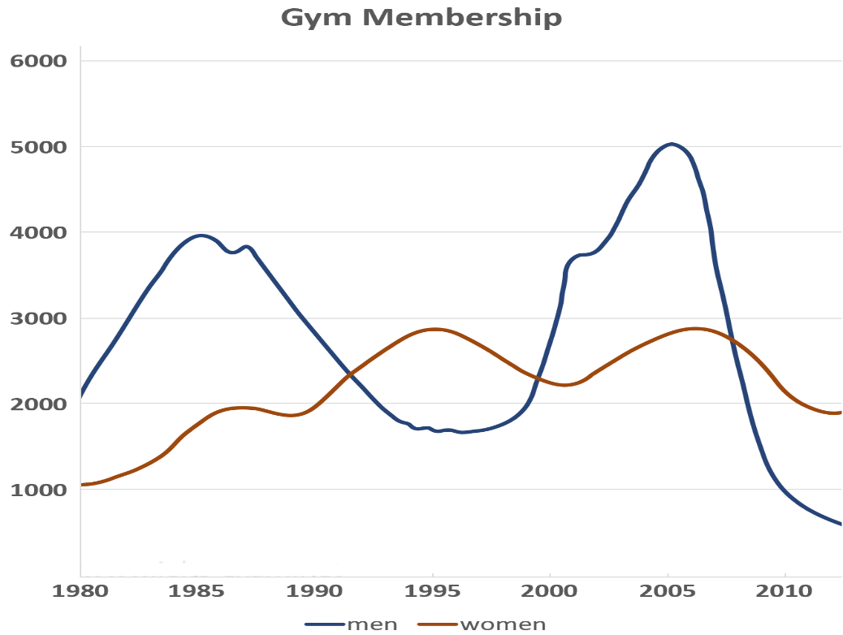

Overview: -----------------------------------------------------------------------------------------------------------------------------------------------------------------------------------------------------------------------------------------------
------------------------------------------------------------------------------------------------------------------------------
------------------------------------------------------------------------------------------------------------------------------
------------------------------------------------------------------------------------------------------------------------------

You should spend about 20 minutes on this task.

The graph below shows the average monthly change in the prices of three metals during 2014.

Summarise the information by selecting and reporting the main features and make comparisons where relevant.

Write at least 150 words.

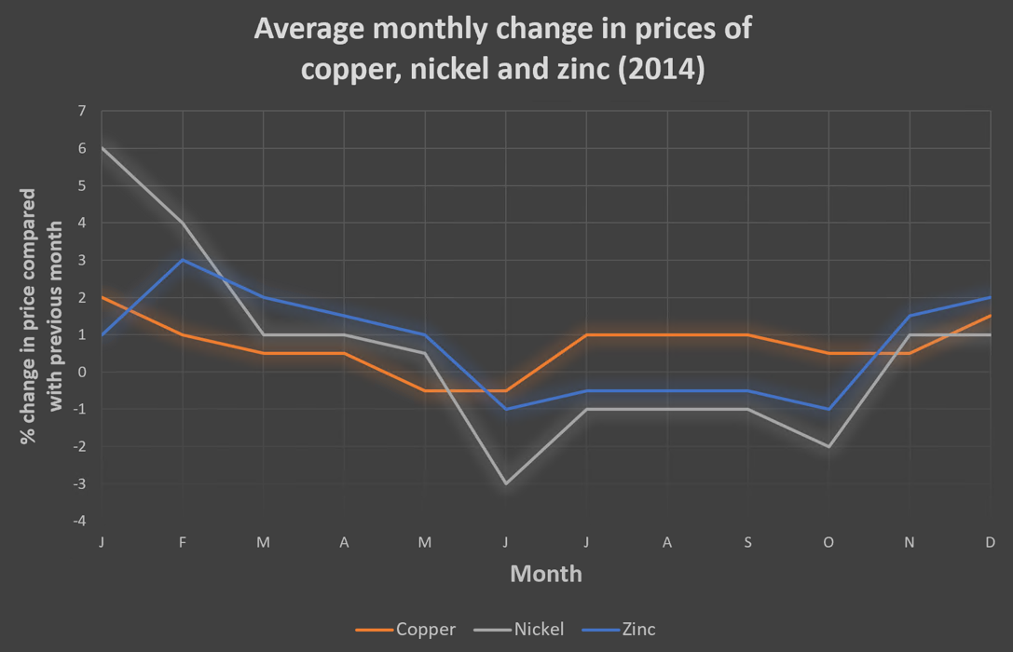

Overview: -----------------------------------------------------------------------------------------------------------------------------------------------------------------------------------------------------------------------------------------------
------------------------------------------------------------------------------------------------------------------------------
------------------------------------------------------------------------------------------------------------------------------
------------------------------------------------------------------------------------------------------------------------------

You should spend about 20 minutes on this task.

The graph shows data about the annual earnings of three bakeries in Calgary, 2000-2010.

Summarise the information by selecting and reporting the main features and make comparisons where relevant.

Write at least 150 words.

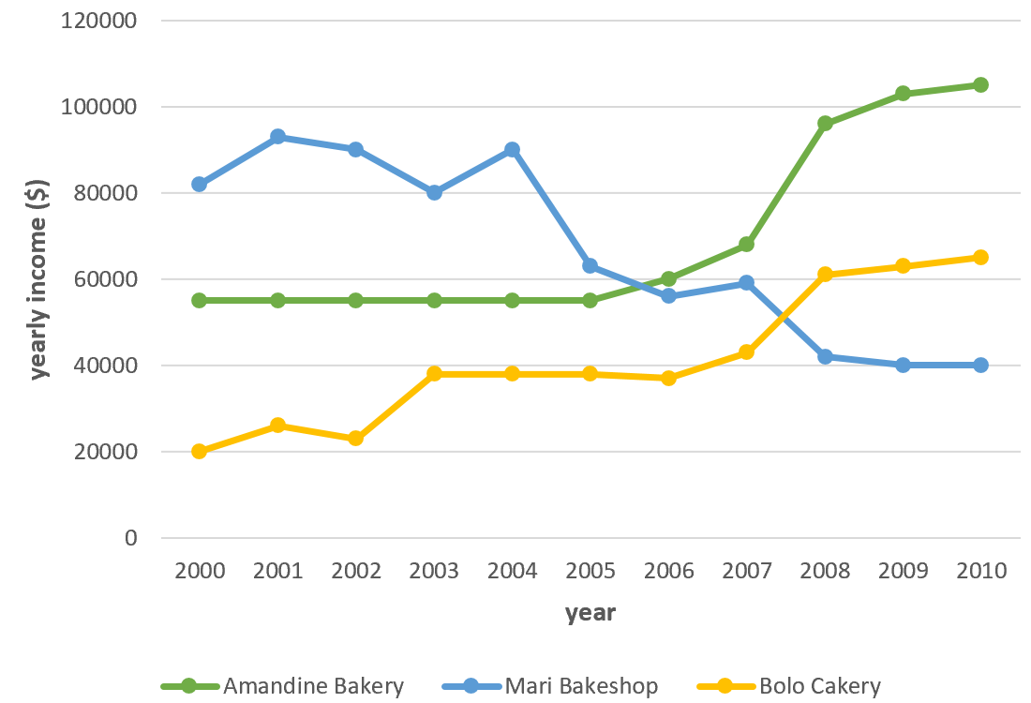

Overview: -----------------------------------------------------------------------------------------------------------------------------------------------------------------------------------------------------------------------------------------------
------------------------------------------------------------------------------------------------------------------------------
------------------------------------------------------------------------------------------------------------------------------
------------------------------------------------------------------------------------------------------------------------------

Table Question Samples
You should spend about 20 minutes on this task.

The table below shows the consumer durables (telephone, refrigerator, etc.) owned in Britain from 1972 to 1983.

Write a report for a university lecturer describing the information shown below.

Write at least 150 words.

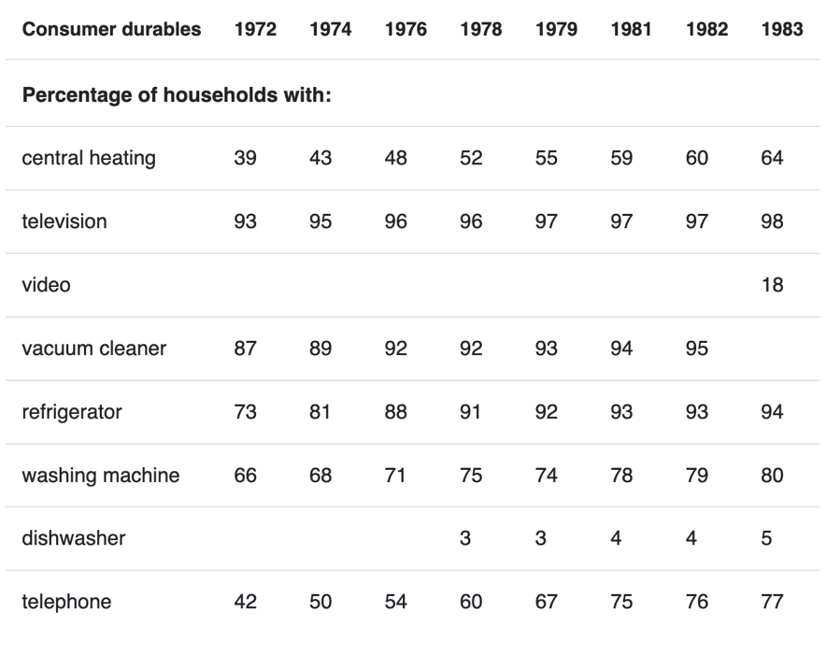

Overview: -----------------------------------------------------------------------------------------------------------------------------------------------------------------------------------------------------------------------------------------------
------------------------------------------------------------------------------------------------------------------------------
------------------------------------------------------------------------------------------------------------------------------
------------------------------------------------------------------------------------------------------------------------------

You should spend about 20 minutes on this task.

The tables below show people's reasons for giving up smoking, and when they intend to give up.

Summarise the information by selecting and reporting the main features, and make comparisons where relevant.

Write at least 150 words.

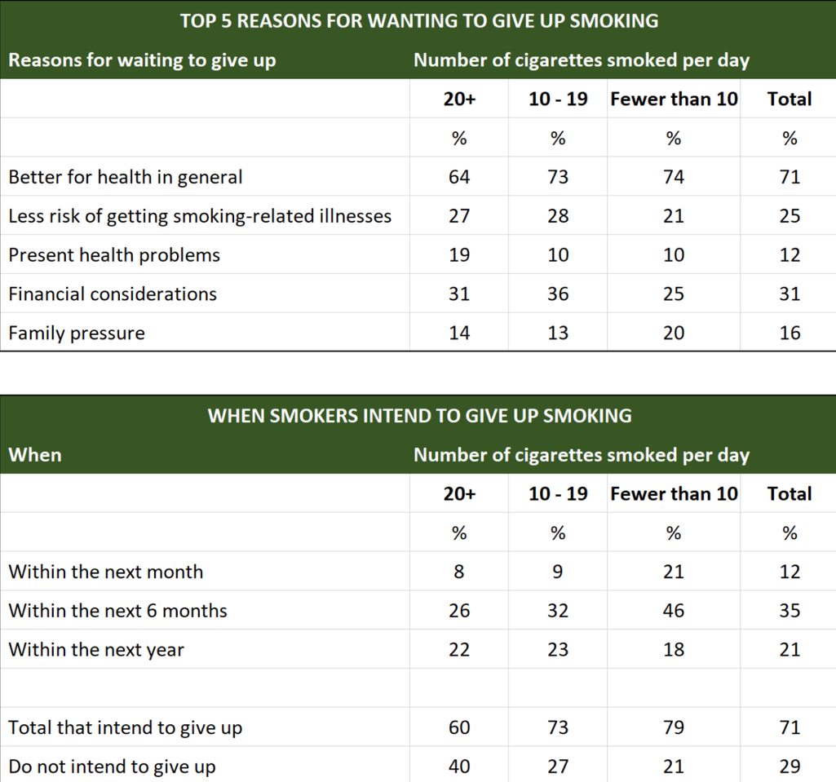

Overview: -----------------------------------------------------------------------------------------------------------------------------------------------------------------------------------------------------------------------------------------------
------------------------------------------------------------------------------------------------------------------------------
------------------------------------------------------------------------------------------------------------------------------
------------------------------------------------------------------------------------------------------------------------------

You should spend about 20 minutes on this task.

The table below shows the changes in some household types in Canada from 1984 to 2020.

Summarise the information by selecting and reporting the main features, and make comparisons where relevant.

Write at least 150 words.

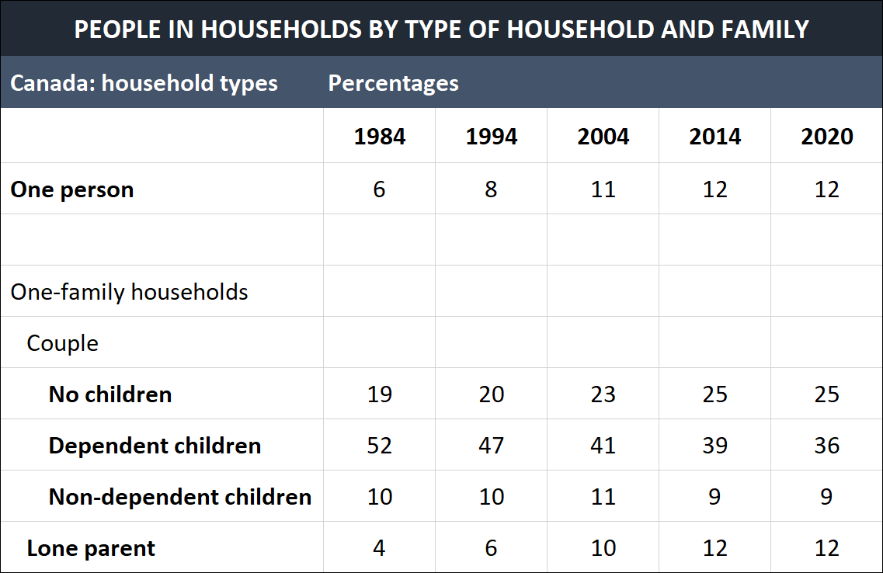

Overview: -----------------------------------------------------------------------------------------------------------------------------------------------------------------------------------------------------------------------------------------------
------------------------------------------------------------------------------------------------------------------------------
------------------------------------------------------------------------------------------------------------------------------
------------------------------------------------------------------------------------------------------------------------------

You should spend about 20 minutes on this task.

The table below shows top ten countries with largest population in 2019, and how it is projected to change by 2100.

Summarise the information by selecting and reporting the main features, and make comparisons where relevant.

Write at least 150 words.

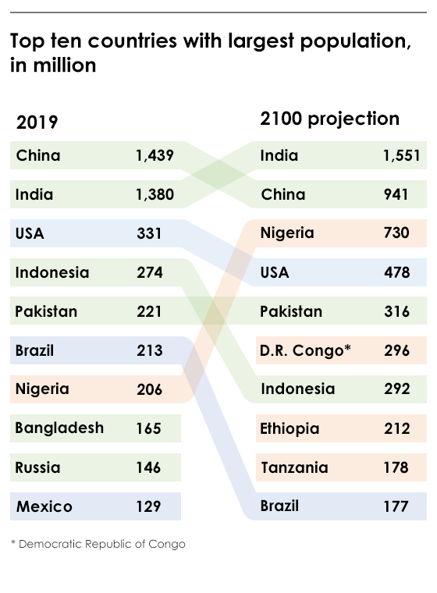

Overview: -----------------------------------------------------------------------------------------------------------------------------------------------------------------------------------------------------------------------------------------------
------------------------------------------------------------------------------------------------------------------------------
------------------------------------------------------------------------------------------------------------------------------
------------------------------------------------------------------------------------------------------------------------------

Process/Diagram Question Samples
You should spend about 20 minutes on this task.

The diagrams below give information about the manufacture of frozen fish pies.

Summarise the information by selecting and reporting the main features, and make comparisons where relevant.

Write at least 150 words.

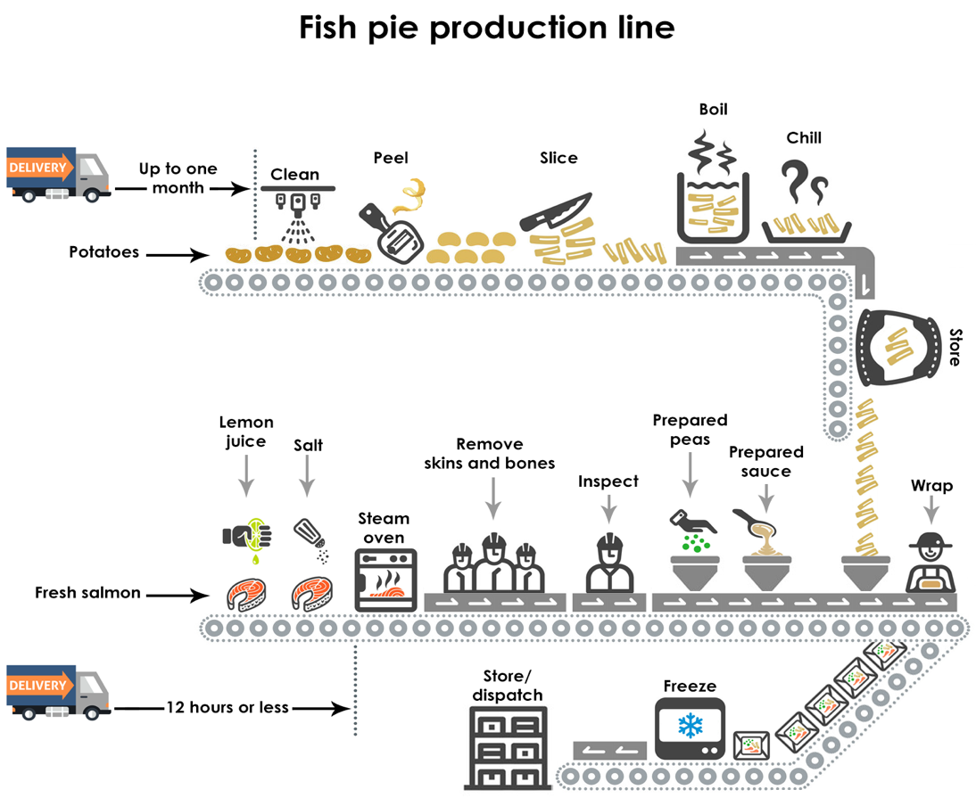

Overview: -----------------------------------------------------------------------------------------------------------------------------------------------------------------------------------------------------------------------------------------------
------------------------------------------------------------------------------------------------------------------------------
------------------------------------------------------------------------------------------------------------------------------
------------------------------------------------------------------------------------------------------------------------------

You should spend about 20 minutes on this task.

The diagram below shows a possible future means of home energy production.

Summarise the information by selecting and reporting the main features, and make comparisons where relevant.

Write at least 150 words.

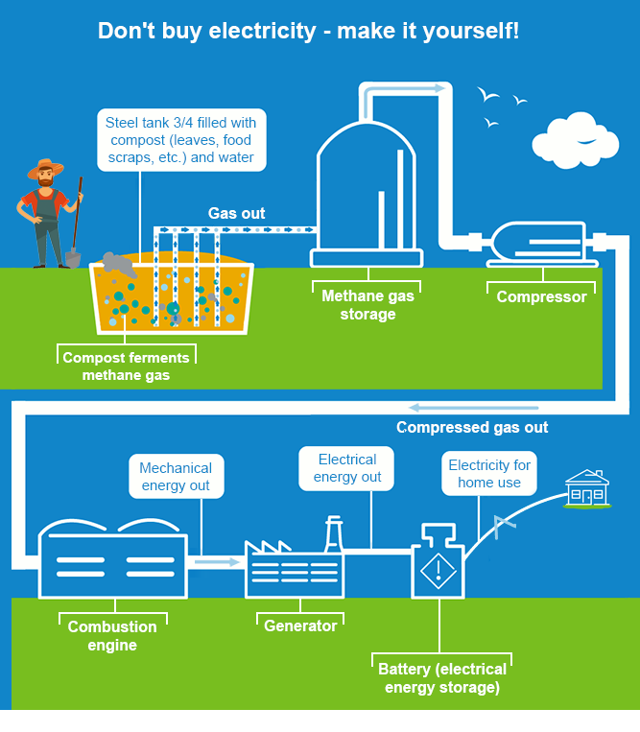

Overview: -----------------------------------------------------------------------------------------------------------------------------------------------------------------------------------------------------------------------------------------------
------------------------------------------------------------------------------------------------------------------------------
------------------------------------------------------------------------------------------------------------------------------
------------------------------------------------------------------------------------------------------------------------------

You should spend about 20 minutes on this task.

The diagram below shows the recycling process of aluminium cans.

Summarise the information by selecting and reporting the main features, and make comparisons where relevant.

Write at least 150 words.

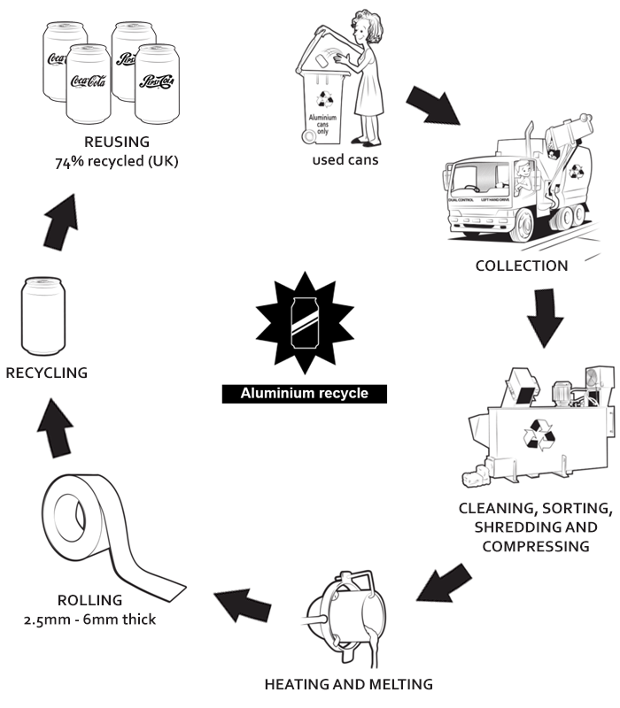

Overview: -----------------------------------------------------------------------------------------------------------------------------------------------------------------------------------------------------------------------------------------------
------------------------------------------------------------------------------------------------------------------------------
------------------------------------------------------------------------------------------------------------------------------
------------------------------------------------------------------------------------------------------------------------------

You should spend about 20 minutes on this task.

The diagram below shows the production of electricity using a system called Ocean Thermal Energy Conversion (OTEC).

Summarise the information by selecting and reporting the main features, and make comparisons where relevant.

Write at least 150 words.

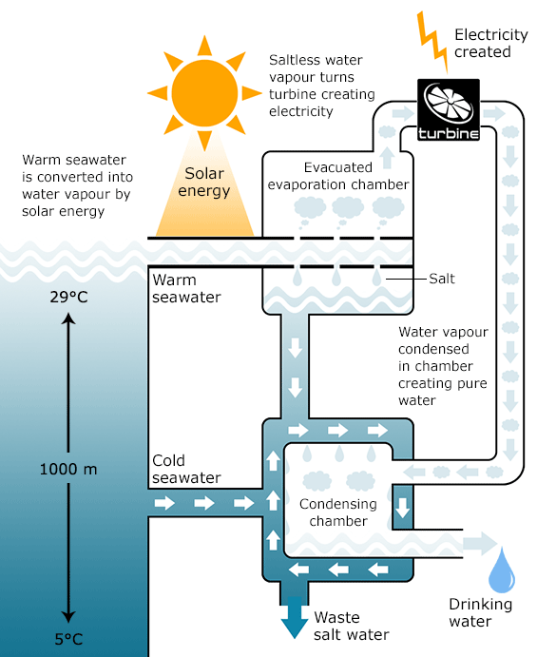

Overview: -----------------------------------------------------------------------------------------------------------------------------------------------------------------------------------------------------------------------------------------------
------------------------------------------------------------------------------------------------------------------------------
------------------------------------------------------------------------------------------------------------------------------
------------------------------------------------------------------------------------------------------------------------------

Combination Question Samples
You should spend about 20 minutes on this task.

The bar chart below shows the estimated sales of jeans for two companies next year in Turkey. The pie chart shows the projected market share of the two companies in jeans at the end of next year.

Write a short report for a university lecturer describing the information shown below.

Write at least 150 words.

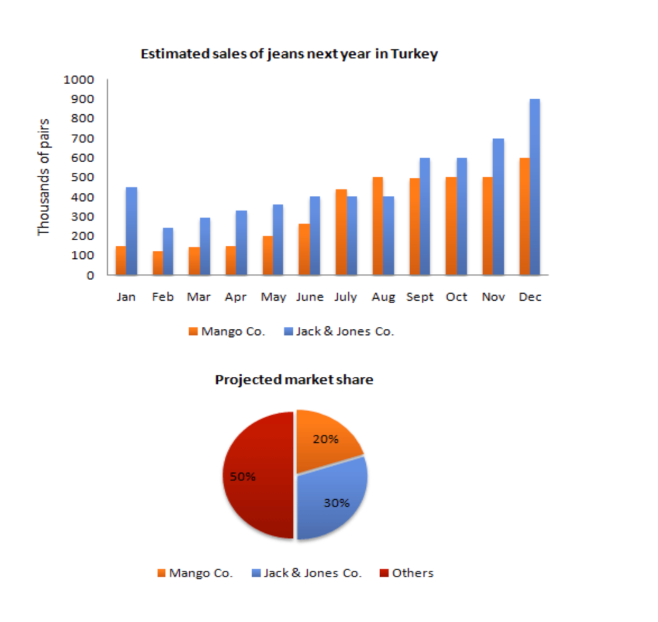

Overview: -----------------------------------------------------------------------------------------------------------------------------------------------------------------------------------------------------------------------------------------------
------------------------------------------------------------------------------------------------------------------------------
------------------------------------------------------------------------------------------------------------------------------
------------------------------------------------------------------------------------------------------------------------------

You should spend about 20 minutes on this task.

The charts A and B show the share of the UK and Australian cinema market in 2001 and cinema admission in the UK and Australia from 1976 to 2006.

Summarise the information by selecting and reporting the main features, and make comparisons where relevant.

Write at least 150 words.

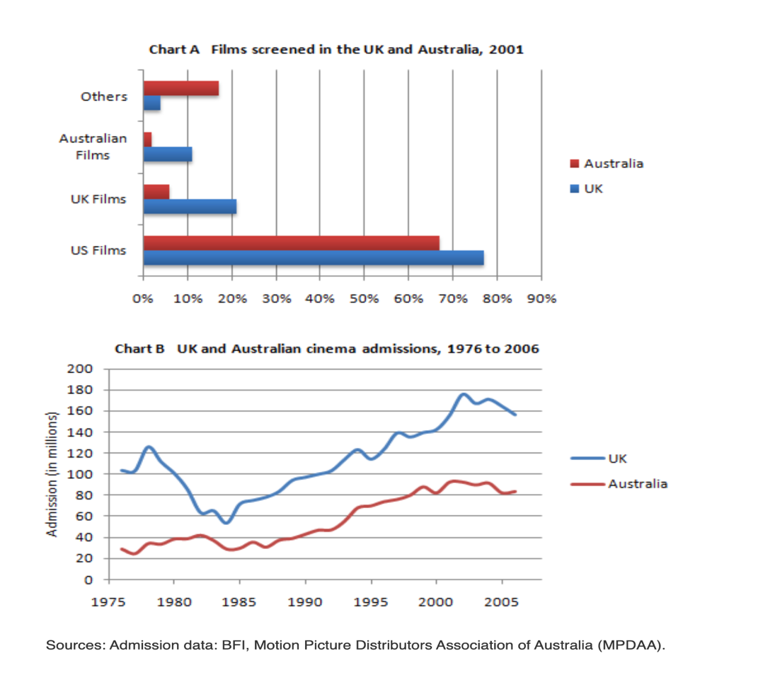

Overview: -----------------------------------------------------------------------------------------------------------------------------------------------------------------------------------------------------------------------------------------------
------------------------------------------------------------------------------------------------------------------------------
------------------------------------------------------------------------------------------------------------------------------
------------------------------------------------------------------------------------------------------------------------------

You should spend about 20 minutes on this task.

The graph below shows the demand for electricity in England during typical days in winter and summer. The pie chart shows how electricity is used in an average English home.

Summarise the information by selecting and reporting the main features, and make comparisons where relevant.

Write at least 150 words.

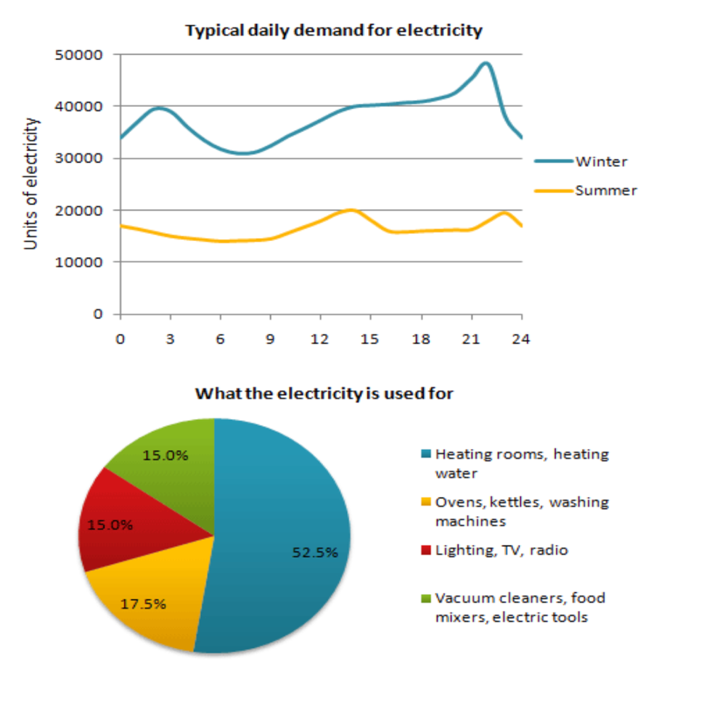

Overview: -----------------------------------------------------------------------------------------------------------------------------------------------------------------------------------------------------------------------------------------------
------------------------------------------------------------------------------------------------------------------------------
------------------------------------------------------------------------------------------------------------------------------
------------------------------------------------------------------------------------------------------------------------------

You should spend about 20 minutes on this task.

The charts below show the percentage of their food budget the average family spent on restaurant meals in different years. The graph shows the number of meals eaten in fast food restaurants and sit-down restaurants.

Summarise the information by selecting and reporting the main features, and make comparisons where relevant.

Write at least 150 words.

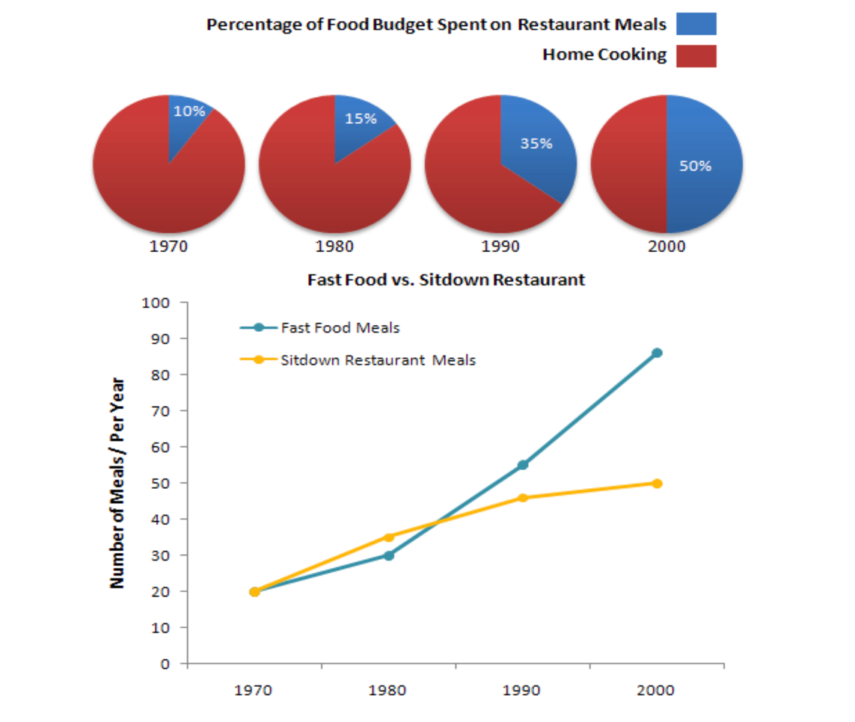

Overview: -----------------------------------------------------------------------------------------------------------------------------------------------------------------------------------------------------------------------------------------------
------------------------------------------------------------------------------------------------------------------------------
------------------------------------------------------------------------------------------------------------------------------
------------------------------------------------------------------------------------------------------------------------------

